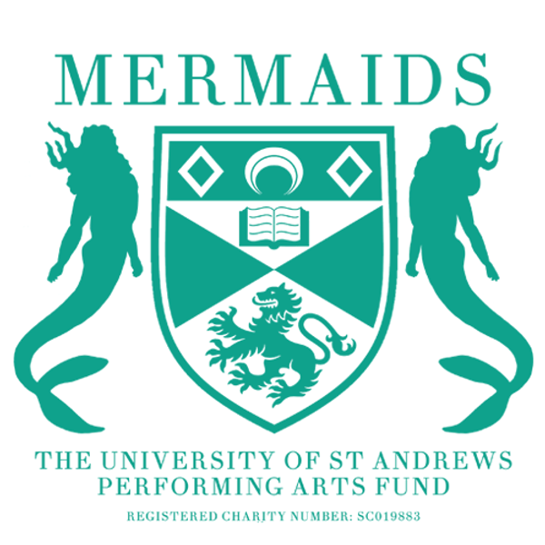

Mermaids at the Fringe
Production Proposal Form
August 2025 – 78th Festival Fringe

As a matriculated student of the University of St Andrews, you have the opportunity to propose any show to the Mermaids Performing Arts Fund, and we will do everything we can to try and help you make it a reality.

To propose a show to Mermaids, you need to fill in a:
- Production Proposal Form
- Budget Form
- The Union’s Supplemental Risk Assessment
- Wellbeing and Accessibility Plan
  - For advice on filling out any of the above, contact the Fringe Representative, Romo (mermaidsfringe@st-andrews.ac.uk).

Please ensure you include as much detail as possible, particularly in Section 4 (production ideas). The more details you include, the more likely it is that we will be able to pass your show.
For clarity, below are the key attributes that we are constitutionally allowed, and obligated, to consider when considering show proposals:

- Financial Merit: Successful proposals will have all spending adequately accounted for with a maximum break-even of 25% for Fringe shows (see budget sheet for details).
- Logistical Merit: Successful proposals must suit Mermaids available venue space and show dates; be logistically viable in terms of actor demands and resources needed for the show; and be suitable from a wellbeing perspective.
- Skills-based merit: Successful proposals should provide opportunities for students to enhance their knowledge and skills in performing arts and show potential for improved engagement with wider areas of the St Andrews student community.

Please submit your proposal documents to mermaidsfringe@st-andrews.ac.uk by 23.59 on the 31st of January 2025.

SECTION 1: PRODUTION DETAILS

Name of Production:
Author:

Why this play?

Forty Word Blurb (including title):

Proposed Dates (delete where appropriate):
The first through the ninth of the month of August in the Year of Our Lord two-thousand and twenty five A.D. C.E. B.A. (Before Armageddon)
11-16 August
18-23 August

Proposed Venue: Willow Studio, Greenside at Riddle’s Court

Would you be willing to cast gender-blind/gender-neutral?

Cast numbers (male/female/neutral parts):

Approximate run time (max 50 mins):

Do you require Production Rights for this piece?

If yes, have they been requested? *Please attach any correspondence*
Advice on requesting Production Rights:
Email the licensor of the rights, stating that you are a student looking to put on an amateur student production of this show, stating your proposed venue and timeframe (ie Spring 2025). Ask if these rights will be available.
Do not panic if you get an unclear answer.
Screenshot the entire email thread and insert it here.

Owner/Handler of Rights and Contact Details:

Will you be seeking funding from another body to support this production? (Antony Tudor, for instance).

SECTION 2: MUSIC RIGHTS

To comply with music rights law, all performances at the Fringe must submit a declaration of music usage when the show is registered. To help us with this process, please answer the following questions.

Will you be using music in your production? YES / NO
Please note that this does not apply to any music played as the audience enters, prior to the beginning of the play/the curtain rising.

If ‘NO’, leave the rest of this section blank.

Is the music 100% originally composed for your production? YES / NO

If ‘YES’, leave the rest of this section blank.

Is the music: INCIDENTAL / INTERPOLATED / BOTH

Have you received permission to use any interpolated music? YES / NO

Note: permission is not required or expected for a proposal, only once the show is passed.

Definitions:

Incidental or ‘curtain’ music: Incidental music refers to music that is not performed by, or audible to a character within the dramatic performance. It is music that may transition a scene change, refer to an underscore or music played at curtain raising or closure.

If using incidental music, PRS fees are covered by Greenside Venues.

Interpolated music: Interpolated music refers to music is part of the drama and it is audible to characters, even if they don’t directly react to it.

If using interpolated music a more complex system applies, discuss with our Fringe Representative Romo (mermaidsfringe@st-andrews.ac.uk), and he will be able to help you find out how much money you should include in your proposed budget.

SECTION 3: PRODUCTION TEAM

All production teams must have a Director, Producer, and Publicist in order to propose. Once passed, production teams must also have a Wellbeing Coordinator (see Wellbeing and Accessibility Plan).

We would also suggest having a Technician, Stage Manager, Costumer, and Set Designer should your show need these team members. One person can take on multiple roles within reason. Please tell us about your team’s previous experience in as much detail as possible and include contact information. If you are proposing as a production company, please mention this here, too!

Director (Name/Email):

Producer (Name/Email):

Publicist (Name/Email):

Technician (Name/Email):

Other Team Members (Name/Email):

SECTION 4: PRODUCTION IDEAS

This section gives us a chance to share your creative vision for the production and understand your budget form in more detail. We do not expect your ideas to be set in stone at this early point, but we hope your budget won’t change drastically from what is passed, so think through what you need and please cross-reference to your production budget. The best way to think about this is to present an scene-by-scene breakdown of your needs. Please contact the appropriate committee members (details below) to check that your estimates are realistic.

Set: (Please remember that your set must be set up every day in ten minutes, and anything that cannot fit into a one-meter cubed storage area must travel with you to/from the venue.)

Props: (Please remember that your set must be set up every day in ten minutes, and anything that cannot fit into a one-meter cubed storage area must travel with you to/from the venue.)

Costumes: (Please remember that you will share dressing rooms with the other performances at Greenside and should be prepared to transport costumes to/from the venue.)

Make-up and Hair: (Please remember that all dressing rooms are shared at Greenside.)

Lighting: (Please remember that all programming will occur during your brief technical rehearsal shortly before your run. We recommend bringing a flash drive for personal backups.)

Sound: (We recommend using QLab for any sound effects or music used during your performance. You will have access to one 3.5mm jack.)

SECTION 5: MARKETING PLAN

Include ideas for how you would market your play. Include ideas for graphic design and both social media and any physical publicity. Also consider the timeframe of your marketing, and any events (i.e., film screening) you may run. Cross-reference with your budget. Additionally, seek advice from our website https://www.mermaidstheatre.com/marketing-informations. (Contact the Mermaids Marketing Officer, Cameron Collier for advice at mermarketing@st-andrews.ac.uk)

SECTION 6: ENGAGEMENT AND OUTREACH

Please detail any ideas to collaborate with other societies, subcommittees, or charities. This could include joint events such as socials or discussions, awareness talks, common publicity or including them in the programme. Furthermore, please attach any correspondence you have had with them. Please explain how these actions will expand your reach within the student body and engage new sets of students.

SECTION 7: COMMITTEE CORRESPONDENCE

Who on the committee have you spoken to already?
If relevant, attach correspondence.

Committee Contact Details:

President: Louise Anderbjörk (merpres@st-andrews.ac.uk)
Vice President: Bella Hirst (ih64@st-andrews.ac.uk)
Secretary: Roslyn Bates (mermaids@st-andrews.ac.uk)
Productions Treasurer: Erin Loftus-Reid (mermtreasurer@st-andrews.ac.uk)
Productions Coordinator: Lucy Turner (merprodcoordinator@st-andrews.ac.uk)
Fringe Representative: Robert (RoMo) Moran (mermaidsfringe@st-andrews.ac.uk)
Barron Manager: Ami Melville (barron@st-andrews.ac.uk)
Tech and Safety Officer: Sofia David (asd20@st-andrews.ac.uk)
Operations Manager: Carrie Cheung (kwc3@st-andrews.ac.uk)
Christmas Ball Convenor: Lucy Callaghan
Box Office Manager: Amalia Villegas (barronboxoffice@st-andrews.ac.uk)
Marketing Officer: Cameron Collier (mermarketing@st-andrews.ac.uk)
Engagements Officer: Caitlin Steele (mermsengagement@st-andrews.ac.uk)
Costumes Officer: Amelia Thompson (agt6@st-andrews.ac.uk)
Set and Props Officer: Sara Whiteman (merprops@st-andrews.ac.uk)

